

**MHMessenger**

**SYSTEM OPERATION DOCUMENT**

**MAB/GROUP IT/SOD/MHMessenger/V1.6**

##### Prepared by :

##### MOBILITY Team

##### Application Management Services (AMS)

##### Group IT

**ALL INFORMATION CONTAINED HEREIN IS RESTRICTED AND SHALL BE KEPT FOR INTERNAL USE ONLY**. None of this information shall be divulged to persons other than Malaysia Airlines Berhad employees and contractors authorized by the nature of their duties to receive such information, or individuals or organisations authorised by Malaysia Airlines Berhad in accordance with existing policy regarding release of company information.

**INTENTIONALLY LEFT BLANK**

|  |  |  |  |  |  |  |  |
| --- | --- | --- | --- | --- | --- | --- | --- |
|  | |  | |  | |  | |
| Prepared By | | : | |  | |
|  | |  | | Krishnakant Bairagi | |
|  | |  | | AMS Mobility | |
|  | |  | | Application Management Services | |
|  | |  | |  | |
| Reviewed By | | :  : | | |  | | --- | |  | | Suman Guduru | | OST Tower Manager | | Group IT | | |
|  | |  | | Noor Hafiza Bahruddin | |
|  | |  | | IT - Service Delivery Management | |
|  | |  | | Group IT | |
|  | | : | |  | |
|  | |  | | Mohd. Suhaimi Yusof | |
|  | |  | | Head.IT Business IT Operations  IT- Business IT Operations | |
|  | |  | |  | |
| Approved By | | : | |  | |
|  | |  | | Siti Hafsah Mohd Desa | |
|  | |  | | Head IT Service Delivery Manager | |
|  | |  | | Group IT | |

**INTENTIONALLY LEFT BLANK**

**TABLE OF CONTENTS**

**Contents Page**

**PART 1** **- MANUAL ADMINISTRATION 1-1**

**1.1.** **RECORD OF REVISION 1-2**

**1.2.** **LIST OF EFFECTIVE PAGES 1-2**

**1.3.** **DISTRIBUTION LIST 1-2**

**1.4.** **LIST OF ABBREVIATIONS 1-2**

**1.5.** **CONDITION OF USE 1-3**

**1.6.** **CONTROL OF MANUAL 1-3**

**PART 2** **- MANUAL BACKGROUND 2-1**

**2.1** **INTRODUCTION 2-2**

**2.2** **PURPOSE 2-2**

**2.3** **SCOPE AND APPLICATION 2-2**

**2.4** **TERMINOLOGY 2-2**

**2.5** **REFERENCES 2-2**

**PART 3** **- OVERVIEW OF BUSINESS PROCESS 3-1**

**3.1** **OVERVIEW OF BUSINESS PROCESS 3-2**

**PART 4** **- MANUAL CONTENT TITLE 4-1**

**4.1** **Systems overview 4-2**

4.1.1 System Concept Diagram 4-2

4.1.2 MHMESSENGER - System Usage 4-3

4.1.3 MHOPS - TRANSIT CHECKLIST 4-5

**4.2** **INTERFACES 4-12**

4.2.1 User Interfaces 4-12

4.2.2 System Interfaces 4-13

**4.3** **WARRANTY AND MAINTENANCE PERIOD 4-13**

**4.4** **ROLES AND RESPONSIBILITIES 4-14**

**4.5. TECHNICAL SPECIFICATIONS** **4-15**

4.5.1 Hardware specifications 4-15

4.5.2 Software specifications 4-17

4.5.3 Communication / Network Specification 4-17

4.5.4 User and Equipment Locations 4-17

4.5.5 File Management 4-17

**4.6** **TECHNICAL OPERATIONS GUIDE 4-18**

4.6.1 Backup and Recovery 4-18

4.6.2 Monitoring Tools 4-18

4.6.3 Source Code Version Control 4-18

4.6.4 Preparation of Production Environment 4-19

**4.7** **Maintenance and support 4-19**

4.7.1 Problem Logging 4-20

4.7.2 Problem Categorization and Escalation 4-20

4.7.3 Application / Technical Support 4-20

**4.8** **User guide 4-20**

4.8.1 Accessing the Application 4-21

**4.9** **Contract management 4-21**

**4.10** **INFORMATION SECURITY 4-22**

4.11.1 Audit and Compliance Requirements 4-23

4.11.2 Password Policy Compliance 4-23

4.11.3 User Access Matrix 4-23

**4.11 DOCUMENTATION AND REFERENCES 4-23**

**AppendiX i**

1. - MANUAL ADMINISTRATION

# RECORD OF REVISION

| **No.** | **Description Of Changes** | **Issue No.** | **Rev. No.** | **Author** | **Effective Date** |
| --- | --- | --- | --- | --- | --- |
| 1 | New SOD with MHMessenger with Azure Cloud Server Details (Original) | 1 | 0 | Venkata Sairam K | 11-May-17 |
| 2 | Backup and recovery, description about azure recovery services vault used for Azure VM Backup | 1 | 1 | Venkata Sairam K | 16-May-17 |
| 3 | Fuel order form submission | 1 | 2 | Eswar Babu K N | 16-Jul-18 |
| 4 | MHQuorra is migrated to separate SOD & only MHMessenger is maintained in this document. MHOPS details updated | 1 | 3 | Eswar Babu K N | 05-Sep-18 |
| 5 | MHOPS details updated | 1 | 4 | Eswar Babu K N | 12-Dec-18 |
| 6 | Updated version and AMS support team changes | 1 | 5 | Deepti Jain | 05-09-19 |
| 7 | Updated Contract Management | 1 | 6 | Krishnakant Bairagi | 07-Jul-20 |

# LIST OF EFFECTIVE PAGES

|  |  |  |  |  |  |  |  |  |  |
| --- | --- | --- | --- | --- | --- | --- | --- | --- | --- |
| **Part** | **Page** | **Issue No.** | **Revision No.** | **Effective Date** |  | **Page** | **Issue No.** | **Revision No.** | **Effective Date** |
| 1 | 1-1 | 1 | 0 | 11-05-17 | 4-18 | 1 | 3 | 05-09-18 |
|  | 1-2 | 1 | 0 | 11-05-17 | 4-19 | 1 | 3 | 05-09-18 |
|  | 1-2 | 1 | 6 | 07-07-20 |  |  |  |  |
|  | 1-3 | 1 | 0 | 11-05-17 | 4-20 | 1 | 3 | 05-09-18 |
|  | 1-4 | 1 | 0 | 11-05-17 | 4-21 | 1 | 3 | 05-09-18 |
|  | 1-4 | 1 | 5 | 05-09-19 | 4-21 | 1 | 5 | 05-09-19 |
|  | 1-5 | 1 | 0 | 11-05-17 | 4-21 | 1 | 6 | 07-07-20 |
|  | 1-6 | 1 | 0 | 11-05-17 | 4-22 | 1 | 3 | 05-09-18 |
| 2 | 2-1 | 1 | 0 | 11-05-17 | 4-22 | 1 | 6 | 07-07-20 |
|  | 2-2 | 1 | 0 | 11-05-17 |  |  |  |  |
|  | 2-3 | 1 | 0 | 11-05-17 |  |  |  |  |
|  | 2-4 | 1 | 0 | 11-05-17 |  |  |  |  |
|  | 2-5 | 1 | 0 | 11-05-17 |  |  |  |  |
| 3 | 3-1 | 1 | 3 | 05-09-18 |  |  |  |  |
| 4 | 4-1 | 1 | 3 | 05-09-18 |  |  |  |  |
|  | 4-2 | 1 | 3 | 05-09-18 |  |  |  |  |
|  | 4-3 | 1 | 3 | 05-09-18 |  |  |  |  |
|  | 4-4 | 1 | 3 | 05-09-18 |  |  |  |  |
|  | 4-5 | 1 | 4 | 12-12-18 |  |  |  |  |
|  | 4-6 | 1 | 4 | 12-12-18 |  |  |  |  |
|  | 4-7 | 1 | 4 | 12-12-18 |  |  |  |  |
|  | 4-8 | 1 | 4 | 12-12-18 |  |  |  |  |
|  | 4-9 | 1 | 4 | 12-12-18 |  |  |  |  |
|  | 4-10 | 1 | 4 | 12-12-18 |  |  |  |  |
|  | 4-11 | 1 | 4 | 12-12-18 |  |  |  |  |
|  | 4-12 | 1 | 4 | 12-12-18 |  |  |  |  |
|  | 4-13 | 1 | 3 | 05-09-18 |  |  |  |  |
|  | 4-14 | 1 | 3 | 05-09-18 |  |  |  |  |
|  | 4-15 | 1 | 3 | 05-09-18 |  |  |  |  |
|  | 4-16 | 1 | 3 | 05-09-18 |  |  |  |  |
|  | 4-17 | 1 | 3 | 05-09-18 |  |  |  |  |

# DISTRIBUTION LIST

|  |  |  |
| --- | --- | --- |
| **NAME** | **DEPT / AREA** | **DESIGNATION** |
| Yusni Alias | Operations BIT | System Admin |
| Mohd Suhaimi Yusuf | Operations BIT | System Owner |
| Siti Hafsah Mohd Desa | Group IT | Head IT SDM |
| Wan Mohd Husni Wan Hussein | AMS | AMS SDM |

# LIST OF ABBREVIATIONS

The following are the abbreviations used for the purpose of simplification.

|  |  |
| --- | --- |
| **Abbreviation** | **Denote** |
| MD | Managing Director |
| CFO | Chief Financial Officer |
| NRM | Network and Revenue Management |

# CONDITION OF USE

* + 1. This manual is the property of Malaysia Airlines Berhad.
    2. All copies assigned to individual position(s), section(s) or station(s) is on loan basis. If, for any reason, the position(s), section(s) or station(s) is abolished from the company organization, the respective copy(ies) of the manual must be returned to Head IT Service Delivery Manager.
    3. In the event where the title of the position or section is changed, the department concerned shall inform Head IT Service Delivery Manager promptly.
    4. The content of this manual shall not be copied, or communicated in part or as a whole, to any person not employed by the Company without the express written consent of the Head IT Service Delivery Manager.
    5. It is the responsibility of the holder to ensure that his copy is updated to the latest amendments and is in good state of condition.

# CONTROL OF MANUAL

* + 1. The contents of this manual shall not be deleted, added, or altered in any way without the approval of the Head IT Service Delivery Manager.
    2. Any page which carries an amendment must bear the new revision date. Any line which is amended shall be highlighted by a revision bar (i.e. dark vertical line) drawn close to the amended text on the outside border of the document.
    3. A transmittal letter must accompany the amended pages to advise the holders how to effect the amendment to their copies.
    4. Holders shall notify this department in writing for loss of manual and to obtain a replacement copy. Head IT Service Delivery Manager shall ensure that this manual reviewed at least once a year and effect necessary amendments as and when necessary. Should any person(s) envisage improvements needed for the contents of this manual, the person should direct the request to the Head IT Service Delivery Manager.

**INTENTIONALLY LEFT BLANK**

1. - MANUAL BACKGROUND

# INTRODUCTION

This is the MHMessenger SOD, hereinafter referred to as “the Policy” provides comprehensive operating procedures within the scope and application herein defined in Part 2 Section 3.0 for Malaysia Airlines Berhad (MAB).

# PURPOSE

The objective of this document is to provide relevant information required to support and maintain MHMessenger application

# SCOPE AND APPLICATION

This document covers relevant information required to support and maintain the MHMessenger applications in production. This covers the maintenance operation of the system, database and interfaces

# TERMINOLOGY

|  |  |  |
| --- | --- | --- |
| **S.No** | **Term** | **Description** |
| 1. | AMS | APPLICATION MANAGEMENT SERVICES |
| 2. | DBA | DATABASE ADMINISTRATOR |
| 3. | DBMS | DATABASE MANAGEMENT SYSTEM |
| 4. | LAN | LOCAL AREA NETWORK |
| 5. | OS | OPERATING SYSTEM |
| 6. | LAMP | LINUX APACHE MYSQL PHP |
| 7. | OSS | OPEN SOURCE SYSTEM |
| 8. | LDAP | LIGHTWEIGHT DIRECTORY ACCESS PROTOCOL |
| 9. | 1A FM | ALTEA FLIGHT MANAGEMENT |
| 10 | MHOPS | MH FLIGHT OPERATIONS |
| 11 | AODB | AIR OPERATIONS DATABASE |
| 12 | GH | GROUND HANDLERS |

# REFERENCES

|  | **Document** | **Description** |
| --- | --- | --- |
| 1 | N/A |  |

1. - OVERVIEW OF BUSINESS PROCESS

# OVERVIEW OF BUSINESS PROCESS

* MHMessenger Application is used to for notifying users regarding Flights Details and also notify users regarding Fuel Order forms.
* Figure 1 shows the overall server & client architecture of the application

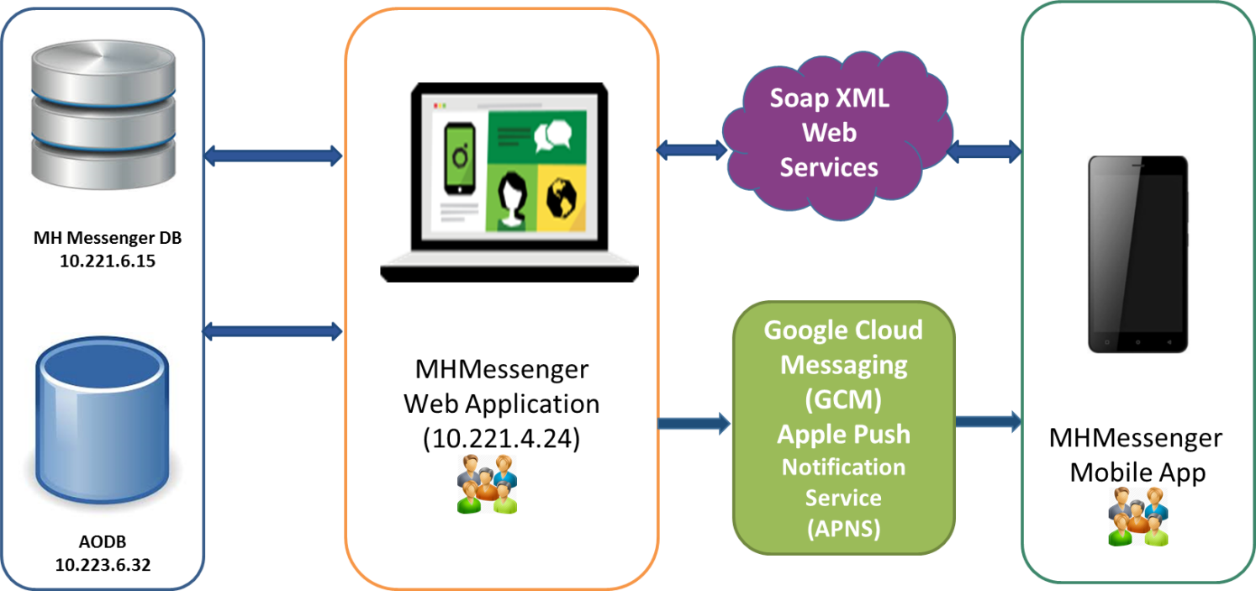

Figure 1 – MHMessenger Overview

1. - MANUAL CONTENT TITLE

4.1 Systems overview

MHMessenger application is developed using Open Source software (OSS) such as Objective-C, Android Java, HTML, CSS, javascript, jQuery, Linux, Apache, MySQL and Java.

## 4.1.1 SYSTEM CONCEPT DIAGRAM

Figure 2 & Figure 3 shows the architecture of the application

**Mobile Applications**

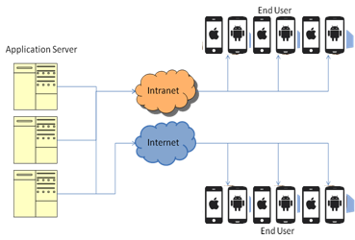

Figure 2 – System Overview for Mobile

**Web Applications**

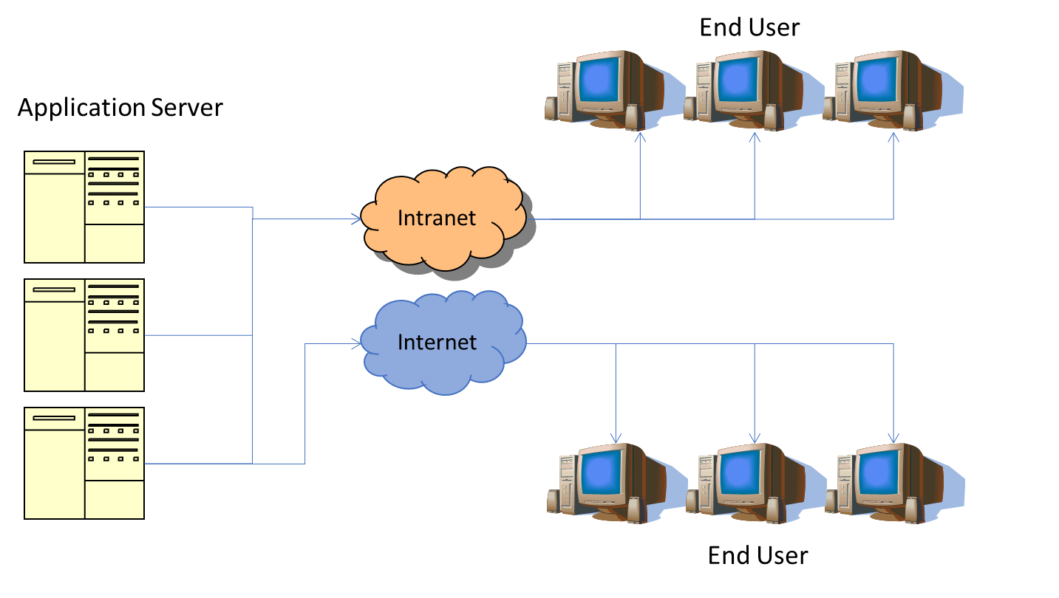

Figure 3– System Overview for Web

## 4.1.2 MHMESSENGER - System Usage

**User Management**

* MHMessenger mobile app has auto registration feature for which users has to provide MH Staff ID & domain password to get registered.
* Admin will have access to the web portal where users can be assigned to flight groups to receive flight/crew notification messages.
* System admin will also have access to create user group.
* In addition to auto-registration, admin will have access to create users under manage users module.
* Mobile number is mandatory for the users created using web portal as all the notification messages will be sent out as SMS to those users if assigned to particular group

Below figure shows the sample screen for user management in the application

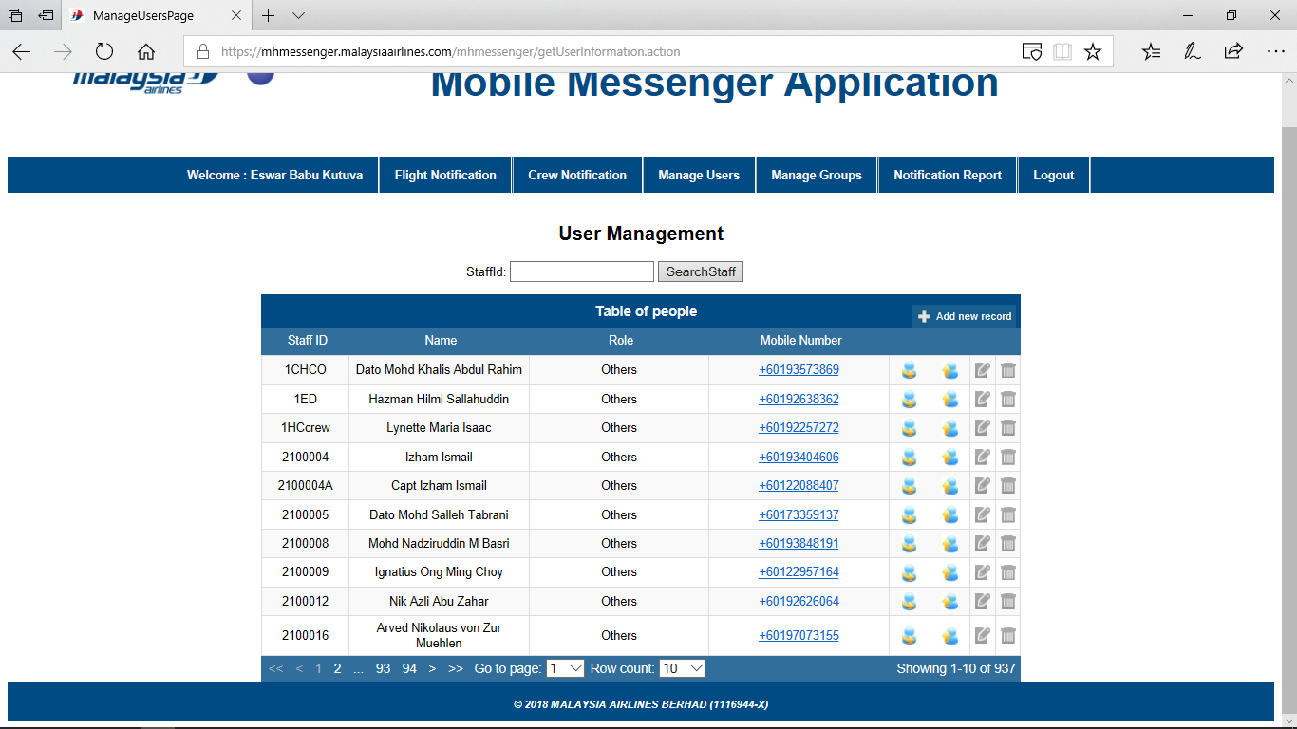

Figure 4 – User Management

Below figure shows the group management feature of the application

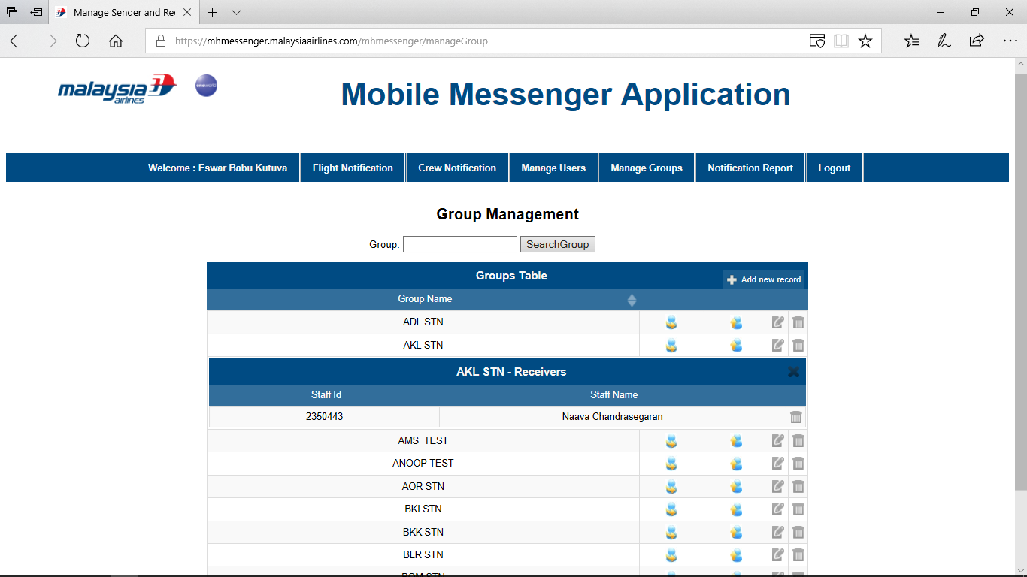

Figure 5 – Group Management

**Flight & Crew Notification**

* All crew/flight notification messages are sent through web portal.
* Users assigned with sender access to a group will be able to send flight/crew notification messages. For those users who are assigned with receiver access will only receive notifications but he/she will not be able to send messages using web portal
* Flight Messages are limited to 150 characters
* For those users with valid mobile number & not registered through MHMessenger mobile app, SMS will be used for communication of flight/crew messages
* PUSH notifications will be sent to those users who have installed & registered using mobile app
* In mobile app, users can view all the flight/crew notifications received for them

Below screen shows the flight notification feature of the application

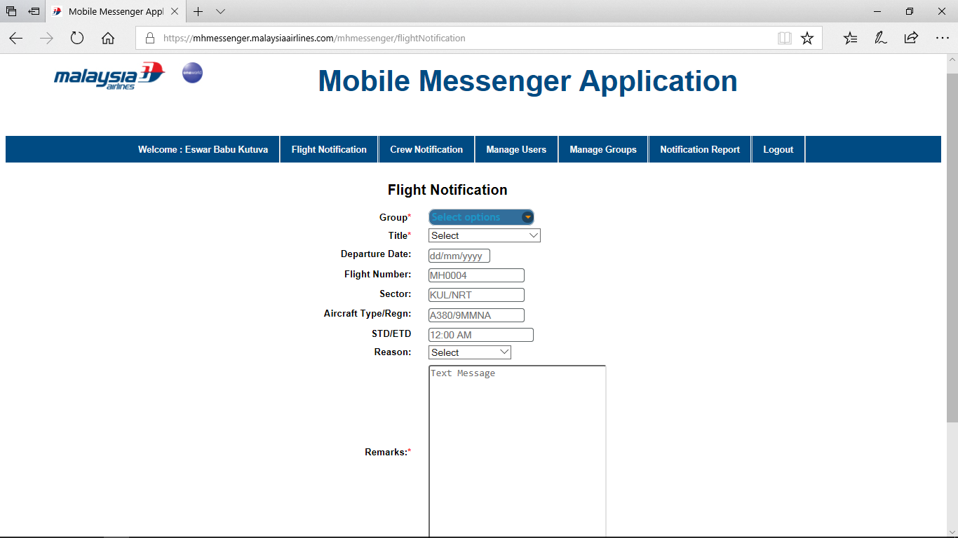

Figure 6 – Flight Notification

**Fuel order updates**

* BPM will send updated fuel figures to MHMessenger and it can be viewed through mobile app
* BPM sends the fuel figures to particular users automatically who are registered in MHMessenger.
* Mobile app will also show the history of fuel order previously submitted for the flight
* Users will be given option to update the fuel figures if necessary
* On successful submission, fuel figures will be updated in Amadeus FM & BPM systems automatically

# 4.2 INTERFACES

## 4.2.1 USER INTERFACES

MOBILITY consisted of many mobile applications targeted for iOS & Android platforms and admin web-applications that are used by various departments in MAB. Users of MOBILITY access the mobile applications from their mobile devices (iOS & Android) and web applications via specific URLs using web browser.

List of MHMessenger service details in the list below.

|  |  |  |
| --- | --- | --- |
|  | **Interfaced system** | **Description** |
| 1 | **Intranet**  <http://mhmessenger.mas.net/mhmessenger/>  **Internet**  <https://mhmessenger.malaysiaairlines.com/> | MHMessenger Application |
| 2 | [https://mhmessenger.malaysiaairlines.com/](https://mhmessenger.malaysiaairlines.com/mhmessenger/) | MHMessenger Android Mobile Application |
| 3 | OTA ipa download link in login page in below URL(s)  **Intranet**  <http://mhmessenger.mas.net/mhmessenger/>  **Internet**  [https://mhmessenger.malaysiaairlines.com/](https://mhmessenger.malaysiaairlines.com/mhmessenger/) | MHMessenger iOS Mobile Application |

Table 7 – User Interfaces

## 4.2.2 SYSTEM INTERFACES

* MHMessenger is using LDAP to authenticate user. User can login into application using MH domain credentials and it will be validated using LDAP validator.
* 1A Interface:

MHMessenger is interfaced to 1A PSS system using web-services through EAI-B2B systems. It uses 1A services for updating final fuel figures in Flight Management (FM) system.

* AODB/BPM Interface:

MHMessenger is interfaced to the AODB using JDBC & BPM using web services. Fuel order updates are exchanged through BPM.

* AODB2 Interface:

MHMessenger is interfaced to the AODB2 using JDBC. This interface is being used to pull out information for MHOPS flight rosters of Ground Handlers

* SMS & PUSH:

MHMessenger uses Maxis-SMS service through EAI layer which is used to send notifications to those users without MHMessenger apps installed on their mobiles. For those installed, PUSH notifications are been sent through GCM & APNS notification services.

# 4.3 WARRANTY AND MAINTENANCE PERIOD

Below table shows the warranty & maintenance period of the application

|  |  |  |
| --- | --- | --- |
|  | **Start Date** | **End Date** |
| Technical cutover to production | 14-Mar-15 | 14-Mar-15 |
| Operational Cutover for EDM | 14-Mar-15 | 14-Mar-15 |
| AMS Support | 14-Mar-15 | NA |

Table 8- Warranty & Maintenance Period

# 4.4 ROLES AND RESPONSIBILITIES

The roles & responsibilities of the application is shown below

|  |  |  |  |  |  |
| --- | --- | --- | --- | --- | --- |
| **Role** | **Responsibility** | **Name** | **Designation** | **Company / Department** | **Contact (Phone & Email)** |
| MAB Group IT Infrastructure Group  (Midrange Team) | * Responsible for maintaining MOBILITY infrastructure. * Responsible backup and restore activity for MOBILITY * Responsible for maintaining web server. * Responsible for troubleshooting infrastructure related problems. | Chinnadurai | Unix Admin | TCS/MIDRANGE | ext_chinnadurai.selvaraj@malaysiaairlines.com |
| MAB Group IT Infrastructure Group  (DB Team) | * Responsible for maintaining database. * Responsible for troubleshooting database related problems. * Creation of new database | Abhinav Kishore | Database Admin | TCS/DBA | Ext_abhinav.kishore@malaysiaairlines.com |
| MAB Helpdesk | * As single point of contact to coordinate when MOBILITY problems occurred. * Responsible to coordinate problem reporting to the respective parties | - | - | - | helpdesk@malaysiaairlines.com  +6 03 7863 2020 |
| Application Support (AMS) | * Responsible for maintaining MOBILITY application as second level support. * Assess OneIT request for MOBILITY. * Develop and unit testing new MOBILITY request * Coordinate UAT with BU. * Work with Infra to deploy new MOBILITY application. | Krishnakant Bairagi | IT Analayst | ATOS/AMS | ext_krishnakant.bairagi@malaysiaairlines.com |

Table 9 – Roles & Responsibilities

*Note: Proper handover must be performed if there is any change to the above roles and the matrix will be updated accordingly.

Below is the responsibility party of the application upon cutover.

|  |  |  |
| --- | --- | --- |
| **No** | **Activity** | **Responsible Party** |
| 1. | Upon cutover of the application to production | * Application is maintained by AMS. * Infrastructure and database is maintained by Infra Team |

Table 10 – Application responsibility

# 4.5 TECHNICAL SPECIFICATIONS

## 4.5.1 Hardware specifications

The hardware specifications of the application is shown below

|  | **Category** | **Configuration** |
| --- | --- | --- |
| 1 | Production Application Server (**Azure Cloud**)  IP: 10.221.4.24  Host Name: 1mobapp1.mas.net | OS : RHEL7  Host Name         : MASG-1MOBAPP1  DNS Name          : 1mobapp1.mas.net  CPU                      : 2  Memory              : 7 GB  Data Disk            : 128 GB |
| 2 | DR Application Server (**Azure Cloud**)  IP: 10.221.4.10  Host Name: 2mobapp1.mas.net | OS : RHEL7  Host Name         : MAHK-2MOBAPP1  DNS                  : 2mobapp1.mas.net  CPU                  : 2  Memory             : 7 GB  DATA Disk           : 128 GB |
| 3 | UAT Application Server (**Azure Cloud**)  IP: 10.221.12.15  Host Name: 3mobapp.mas.net | OS : RHEL7  Host Name         : MASG-3MOBAPP-LX  DNS Name          : 3mobapp.mas.net  CPU                     : 2  Memory              : 3.5 GB  External Disk       : 100 GB |
| 4 | Production Web Server (**Azure Cloud**)  IP: 10.221.2.4  Host Name: 1mobweb1.mas.net | OS : RHEL7  Host Name         : MASG-1MOBWEB1  DNS Name          : 1mobweb1.mas.net  CPU                     : 2  Memory              : 7 GB  Data Disk            : 128 GB |
| 5 | DR WebServer (**Azure Cloud**)  IP: 10.222.2.4  Host Name: 2mobweb1.mas.net | OS : RHEL7  Host Name         : MAHK-2MOBWEB1  DNS                  : 2mobweb1.mas.net  CPU                  : 2  Memory             : 7 GB  DATA Disk           : 128 GB |
| 6 | Production Database Server (**Azure Cloud**)  IP: 10.221.6.15  Host Name: 1mobdb1.mas.net | OS : RHEL7  Host Name         : MASG -1MOBDB1  DNS                  : 1mobdb1.mas.net  CPU                  : 2  Memory             : 7 GB  DATA Disk           : 128 GB |
| 7 | DR Database Server (**Azure Cloud**)  IP: 10.222.6.10  Host Name: 2mobdb1.mas.net | OS : RHEL7  Host Name         : MAHK-2MOBDB1  DNS                  : 2mobdb1.mas.net  CPU                  : 2  Memory             : 7 GB  DATA Disk           : 128 GB |
| 8 | UAT Database Server (**Azure Cloud**)  IP: 10.221.14.12  Host Name: 3mobdb.mas.net | OS : RHEL7  Host Name         : MASG-3MOBDB-LX  DNS Name          : 3mobdb.mas.net  CPU                     : 2  Memory              : 3.5 GB  External Disk       : 100 GB |

Table 11 – Hardware Specifications

## 4.5.2 Software specifications

Software specifications are shown below

|  |  |  |
| --- | --- | --- |
|  | **Category** | **Configuration** |
| 1 | UAT Application Server : 10.221.12.15 (3mobapp.mas.net)  UAT Database Server : 10.221.14.12 (3mobdb.mas.net)  Prod Web Server : 10.221.2.4 (1mobweb1.mas.net)  Prod Application Server : 10.221.4.24 (1mobapp1.mas.net)  Prod Database Server : 10.221.6.15 (1mobdb1.mas.net)  DR Web Server : 10.222.2.4 (2mobweb1.mas.net)  DR Application Server : 10.221.4.10 (2mobapp2.mas.net)  DR Database Server : 10.222.6.10 (2mobdb1.mas.net) | java-1.8.0-openjdk-1.8.0.111-2.b15.el7_3.x86_64  MySQL - 5.7.16  Apache Tomcat 8.5.9  apache-2..4.23 |

Table 12 – Software Specifications

**4.5.3 COMMUNICATION / NETWORK SPECIFICATION**

The server is accessible through TCP/IP LAN/WAN connection. Users using their desktop browser can access the application over the LAN connection to the server. The current supported browser is Googlr Chrome

The network specifications are shown below

|  |  |  |
| --- | --- | --- |
|  | **Category** | **Configuration** |
| 1 | Web Port 80 | MASG-3MOBAPP-LX |
| 2 | Web Port 80 | MASG-1MOBAPP1 |
| 3 | Web Port 3036 (DB) | MASG-3MOBDB-LX |
| 4 | Web Port 3036 (DB) | MASG -1MOBDB1 |

Table 13 – Communication Specification

## 4.5.4 User and Equipment Locations

MHMessenger application is used by various departments in MAB. Users and user’s equipment locations are distributed over MAB network at the various departments and stations.

## 

## 4.5.5 File Management

N/A

### 4.5.5.1 DBMS setup

MOBILITY uses MySQL as the DBMS.

Attach is the list of databases and tables defined for MHMessenger:

|  |  |  |  |
| --- | --- | --- | --- |
|  | **MOBILITY Application** | **Database** | **Table defined** |
| 1 | MHMessenger | mhmobile | FORM_DETAIL  IDEA_DETAIL  STAFF_INFO  amadeus_status  batch_notification  crew_table  form_notification_audit  group_mapping  group_master  notification  notification_header  param_config  reply_notification  tract_activity_mast  tract_category_mast  tract_flight_activity_status  tract_flight_category_task_status  tract_flight_details  tract_messages  tract_roster_param  tract_user_group  tract_user_group_map  user_old_devices  user_profile  version |

Table 14 –DBMS Setup

# 4.6 TECHNICAL OPERATIONS GUIDE

NA

### 4.6.1 Backup and Recovery

* Recovery Services vault is an entity that stores all the backups and recovery points that have been created over time. The vault also contains the backup policies that will be applied to the virtual machines being backed up
* When the Recovery services initiate a backup job at the scheduled time, it triggers the backup extension to take a point-in-time snapshot. The Azure Recovery service uses the VMSnapshot extension in Windows, and the VMSnapshotLinux extension in Linux. The extension is installed during the first VM backup.
* Once the Azure Backup service takes the snapshot, the data is transferred to the vault. To maximize efficiency, the service identifies and transfers only the blocks of data that have changed since the previous backup.
* When the data transfer is complete, the snapshot is removed and a recovery point is created

Please find server backup details below.

|  |  |  |  |  |
| --- | --- | --- | --- | --- |
| **Hostname** | **Version** | **Schedule** | **Frequency** | **Remarks** |
| MASG-1MOBAPP1 | 6 | Every Saturday | 5:30 PM MYT | Monthly first Saturday backupretention is 3 months |
| MASG-1MOBWEB1 | 6 | Every Saturday | 5:30 PM MYT | Monthly first Saturday backupretention is 3 months |
| MASG -1MOBDB1 | 6 | Every Saturday | 5:30 PM MYT | Monthly first Saturday backupretention is 3 months |
| MAHK-2MOBAPP1 | 4 | Every Saturday | 8:00 PM MYT | Monthly first Saturday backupretention is 2 months |
| MAHK-2MOBWEB1 | 4 | Every Saturday | 8:00 PM MYT | Monthly first Saturday backupretention is 2 months |
| MAHK -2MOBDB1 | 4 | Every Saturday | 8:00 PM MYT | Monthly first Saturday backupretention is 2 months |
| MASG-3MOBAPP | 4 | Every Saturday | 5:30 PM MYT | Monthly first Saturday backupretention is 2 months |
| MASG-3MOBDB | 4 | Every Saturday | 5:30 PM MYT | Monthly first Saturday backupretention is 2 months |

Table 15 – Server Backup Details

 Please find DB backup details below.

|  |  |  |  |  |
| --- | --- | --- | --- | --- |
| **Hostname** | **Database Version** | **Schedule** | **Frequency** | **Remarks** |
| MASG -1MOBDB1 | MySQL-5.7 | Daily | 9:00 PM MYT | 15 days backup retention |
| MASG-3MOBDB | MySQL-5.7 | Daily | 12:00 PM MYT | 15 days backup retention |

Table 16 – DB Backup Details

## 4.6.2 Monitoring Tools

MOBILITY systems will be monitored by Tivoli & ISOC Team on website availability

## 4.6.3 Source Code Version Control

Below is the procedure for handling the Source Code for websites supported by AMS team:

1. Take the latest script version from the Production environment
2. Copy the version in the test environment. Development and testing is done in the test environment.
3. UAT is perform in the test environment

Upon confirmation, the current version in the production will be back up by renaming with the current-date then the new version is copied to production.

## 4.6.4 Preparation of Production Environment

### 4.6.4.1 Program / Macro

Apache, PHP, Java, MySQL running.

### 4.6.4.2 Network Definitions

All users mobile devices (iOS & Android) are connected to Internet or MH Network to access MHMessenger Application.

All user PCs are connected to the Local LAN or Internet to be able to access the MOBILITY related admin Web Application.

### 4.6.4.3 Mobile Configuration

1. iOS 9.0 & above
2. Android 4.4.2 & above
3. Target Mobile Application Installed

### 4.6.4.4 Desktop Configuration

1. Microsoft office software
2. Web Browser with Java enabled`

## 4.6.5 Batch Jobs

N/A

## 

## 4.6.6 Report Management

N/A

## 

## 4.6.7 Baseline Performance Information

MHMessenger is classified as a Business Criticality Definition (BCD) level 2 applications. There is Disaster Recovery capability for this application. In the event of disaster recovery, the application will be available.

# 

# 4.7 MOBILE APP DEPLOYMENT PROCEDURE

Microsoft Appcenter is used for distributing mobile app internally to all MHMessenger users under MAB

Following are the procedure for distributing mobile apps

* Prepare the executable files for both Android & iOS platform from respective build tools.
* Login into Appcenter and choose the organization “Malaysia Airlines Berhad”
* Under Apps, it will list down all the Apps released by “Malaysia Airlines Berhad”
* Choose MHMessenger with OS type iOS or Android
* Distribution procedure for both Android & iOS remains same in Appcenter
* Once you choose an App, it will redirect to App overview page
* Look for the option “Distribute” under left hand side of the page
* Under Distribution, click on “Groups” and it will list down all the groups created for the app distribution
* Add any new users using their MAB email under the distribution group
* Look for New Release option to start the deployment of a build
* Upload APK file in case of Android and IPA file in case of iOS
* On next screen, fill in appropriate release notes for the build
* On proceeding to next screen, click on distribute to complete the deployment procedure
* All the users will now receive an email from Appcenter for the new release and installation steps are provided under installation guide
* Any new user should receive the signup email from Appcenter, they should complete the registration process before installing the app. Procedures are provided under installation guide

## 4.7.1 Mobile App Installation Guide

Please refer to Documentation and references section

## 4.8 Maintenance and support

The maintenance MOBILITY operations team as listed below

|  |  |  |
| --- | --- | --- |
|  | **Type of Support** | **Contact Details** |
| 1 | IT Helpdesk  (1st Level Support) | (603) 7840-2020, 1-800-88-1173  helpdesk@malayasiaairlines.com |
| 2 | Group IT Operations  (2nd Level Support)  Group IT Operations  (2nd Level Support) | System Administrator (Midrange)  [GD_TCSMidrange@malaysiaairlines.com](mailto:GD_TCSMidrange@malaysiaairlines.com),  DB Administrator  [GD_TCSDatabase@malaysiaairlines.com](mailto:GD_TCSDatabase@malaysiaairlines.com)  Network Administrator  [GD_TCSNetwork@malaysiaairlines.com](mailto:GD_TCSNetwork@malaysiaairlines.com)  SMTP/FTP Administrator  [GD_TCSNetwork@malaysiaairlines.com](mailto:GD_TCSNetwork@malaysiaairlines.com)  For the actual support during the operation period, refer to MAB Helpdesk for up-to date Infra support personnel who are on call.  Application Support  GD_AMS_MHmessenger@malaysiaairlines.com |

Table 17 - Maintenance & Support

## 4.8.1 Problem Logging

MAB IT Helpdesk will handle upon any issue / problem in production.

## 4.8.2 Problem Categorization and Escalation

Helpdesk will analyze the problem and assign a ticket number and a severity level which is mutually agreed by the user based on the Group IT SLA.

For all non-application related problems, Helpdesk will channel the problem ticket to the respective support from Infra- Midrange, Infra-DBA, Infra-Network or Desktop support for PC / browser problems.

MHMessenger is categorized as a business critical application (BCD2), and there should be Severity 1 or 2 or 3 incident expected for MHMessenger.

## 4.8.3 Application / Technical Support

|  |  |  |
| --- | --- | --- |
| **Name** | **Responsibility Area** | **Contact (Email)** |
| IT Helpdesk | L1 support | [helpdesk@malaysiaairlines.com](mailto:helpdesk@malaysiaairlines.com) |
| Chinnadurai | Midrange | ext_chinnadurai.selvaraj@malaysiaairlines.com GD_TCSMidrange <GD_TCSMidrange@malaysiaairlines.com> |
| VishnuKumar B M | Wintel | ext_vishnukumar.bm@malaysiaairlines.com GD_TCSWintel <GD_TCSWintel@malaysiaairlines.com> |
| Abhinav Kishore | Database | [ext_abhinav.kishore@malaysiaairlines.com](mailto:ext_abhinav.kishore@malaysiaairlines.com)  GD_TCSDatabase <GD_TCSDatabase@malaysiaairlines.com> |
| Ravisankar | Network Support | [ext_ravisankar.balasubramanian@malaysiaairlines.com](mailto:ext_ravisankar.balasubramanian@malaysiaairlines.com)  GD_TCSNetwork <GD_TCSNetwork@malaysiaairlines.com> |
| Sankar kanagarathinam | AODB | [ext_sankar.kanagarathinam@malaysiaairlines.com](mailto:ext_sankar.kanagarathinam@malaysiaairlines.com) |
| Krishnakant Bairagi | Application Support | [ext_krishnakant.bairagi@malaysiaairlines.com](mailto:ext_krishnakant.bairagi@malaysiaairlines.com) |
| Group ID | MHMessenger support team | GD_AMS_MHmessenger@malaysiaairlines.com |

Table 18 - Technical Support

# 

# 4.9 USER GUIDE

The high-level descriptions of the MOBILITY application modules are as below:

|  |  |
| --- | --- |
| **Title** | **MHMessenger** |
| **Reference** | http://svn.mas.net/svn/MOBILITY/MHmessenger/Source Code/Service Portal/mhmessenger |
| **Description** | MHMessenger Application |
| **URL** | Android Application:  <https://mhmessenger.malaysiaairlines.com/mhmessenger/>  iOS Application  OTA download link available in below mentioned Web-Portal url(s)  Web Portal:  <https://mhmessenger.malaysiaairlines.com/mhmessenger/>  <http://mhmessenger.mas.net/mhmessenger/> |
| **Requirement & Functionality (High-level)** | **Flight Notification:** One-way communication between administrator and end users  **Staff Notification:** Enables collaboration, Admin initiates the discussion. After that group members can exchange the messages between them  **Flexible user management:** Admin can add/remove/update any user and also can manage the group using a web browser.  **Fuel Order Form:** BPM sends Fuel Order from AODB to MHMessenger to be displayed in the mobile application. Fuel Order can be edited before submitting the same to 1A  **MHOPS**: Integrating task management for Operations team with Ground Handling & Crew Staffs |
| **No. of Users** | 800 |
| **Owner / Key User and Contact Info** | Mohd. Suhaimi Yusof ,Yusni Alias & Aslina Ahmad Asiri |
| **Integration / Interfaces** | B2B Maxis eSMS gateway EAI Interface |

Table 19 – User Guide

## 4.9.1 Accessing the Application

Mobile applications can be accessed by users via their mobile devices connected to Internet or MH Network.

Web application / system can be accessed by users via their workstations through the Network Neighborhood (internet browser)

# 

# 4.10 CONTRACT MANAGEMENT

Contractor / Vendor relationship will be managed via the following contracts.

|  |  |  |
| --- | --- | --- |
| **No** | **Contract** | **Parties** |
| 1. | Service contract from AMS support service | Signed between MAB and ATOS |

Table: Contract Management

# 4.11 INFORMATION SECURITY

## 4.11.1 Audit and Compliance Requirement

Below are the audit & compliance requirements of the application

|  |  |  |
| --- | --- | --- |
| **Activity** | **Frequency** | **Responsible Party** |
| Perform ID review every quarter and submit result to IRS  [Req: ISO 27001, PCI-DSS] | Quarterly | ID Admin |
| Update user access matrix and submit to IRS  [Req: ISO 27001, PCI-DSS] | Yearly | System Owner |
| Install Critical Security Patches for the application and submit report to IRS  [Req: ISO 27001, PCI-DSS] | Quarterly | System Owner |
| Performed Backup restoration  [Req: ISO 27001, PCI-DSS] | Yearly | System Owner |
| Review & update security documentation and submit to IRS:   * Super/privilege IDs and access * Security Controls Setting * Audit Logs setting * System bypass * List of connections and integration * List of used ports * Data encryption setting * Application/system schematic diagram   [Req: ISO 27001] | Yearly | System Owner |

Table 20 - Audit & Compliance Requirement

## 4.11.2 Password Policy Compliance

Application follows the below password policy compliance

|  |  |  |  |  |
| --- | --- | --- | --- | --- |
|  | **Password Policy Requirements** | **Yes** | **No** | **Remarks** |
|  | Password length at least 8 characters (minimum) | Yes |  |  |
|  | Alphanumeric | Yes |  |  |
|  | Change temporary password at first logon | Yes |  |  |
|  | Password expiry = 90 days (maximum) | Yes |  |  |
|  | Password reuse generation = 5 (minimum) | Yes |  |  |
|  | Account lock out after 5 failed login attempts | Yes |  |  |
|  | Application shall disconnect or suspend inactive sessions= 15 Minutes | Yes |  |  |
|  | Wrong password shall be recorded in an audit log | Yes |  |  |

Table 21 - Password Policy Compliance

## 4.11.3 USER ACCESS MATRIX

The user level access matrix of the application is shown below

|  |  |  |  |  |  |
| --- | --- | --- | --- | --- | --- |
| **USER ID/ Common ID** | **USER TYPE** | **ACCESS LEVEL** | | | |
| **Update** | **View** | **Edit** | **Delete** |
|  | Administrator | N.A | N.A | N.A | N.A |
|  | Normal | X | X | X |  |

Table 22 – User Access Matrix

Note: Refer Owner / Key User for each application under User Guide table for administrator role.

# 

# 4.12 DOCUMENTATION AND REFERENCES

Following are the soft copy documentation location

|  | **Document** | **Location and reference** |
| --- | --- | --- |
| 1 | System Operation Document  (soft copy of this document) | <https://mabitdept.sharepoint.com/sites/MyPulse/InformationTechnology/ServiceDeliveryManagement/System%20Operating%20Document%20SOD/Forms/AllItems.aspx> |
| 2 | Mobile App Installation Guide (Android & iOS) | <https://mabitdept.sharepoint.com/sites/MyPulse/InformationTechnology/ServiceDeliveryManagement/System%20Operating%20Document%20SOD/Forms/AllItems.aspx> |

Table 23 - References

**APPENDIX**

**Change Request**

|  |  |  |  |  |
| --- | --- | --- | --- | --- |
| **Change request** | **Date** | **Description** | **MH fix Included?** | **Impacted version** |
| **CHG0018717** | 06-08-2020 | Mysql version upgrade | yes | 1.6 |
| **CHG0019001** | 30-10-2020 | MHMESSENGER- Application code/Configuration changes for Tomcat  upgrade 9.0.36 | yes | 1.6 |





**PATCH MANAGEMENT REPORT**

Application : _______NIL______________________________________________

Owner **: _______**NIL**______________________________________________**

|  |  |
| --- | --- |
| **Date** | **Patch / Service Pack Applied** |
| NIL | NIL |
|  |  |
|  |  |
|  |  |

**Prepared By: Approved By:**

**.................................................... ....................................................**

**System Admin System Owner**

**BACKUP RESTORATION REPORT**

Application : ______NIL________________________________________________

Owner : ______NIL________________________________________________

|  |  |
| --- | --- |
| **Date** | **Status of Restoration** |
| **NIL** | **NIL** |
|  |  |
|  |  |
|  |  |

**Prepared By: Approved By:**

**.................................................... ....................................................**

**Backup Admin System Owner**

**NON COMPLIANCE REPORT**

Application : ______NIL______________________________________________

Owner **: ______**NIL**_______________________________________________**

|  |  |  |
| --- | --- | --- |
| **Date** | **Reference Number** | **Description** |
| **NIL** | **NIL** | **NIL** |
|  |  |  |
|  |  |  |
|  |  |  |

**Prepared By: Approved By:**

**.................................................... ....................................................**

**System Admin System Owner**

**END OF DOCUMENT**